Scrum Meetings
Sprint 2: The following is proof of scrum meetings.
15/04/25
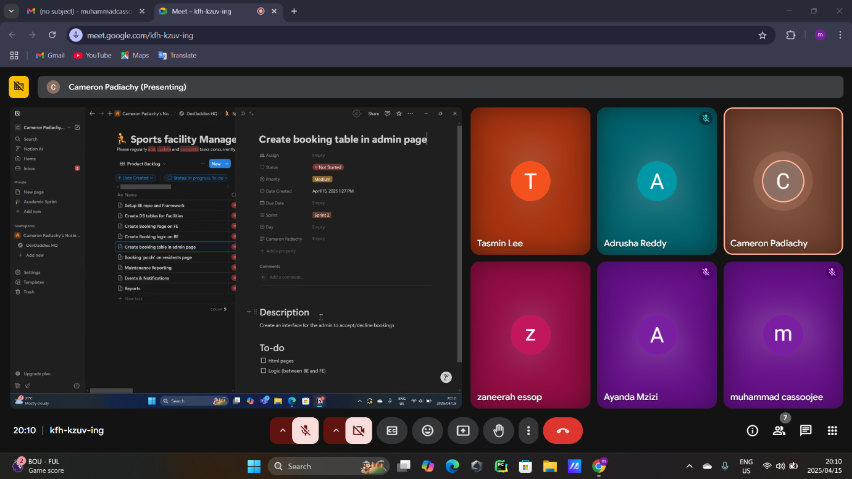
Daily Stand-up Summary 1:
This was our first sprint meeting for sprint 2. In this meeting we analysed the next portion of our project. We used it to identify potential problems or blockers we may encounter with this week’s work. We also began assigning tasks to members for the rest of the week. We identified blockers with the front and back-end clash with notifications. The frontend required the backend to finish off portions of notification code for them to proceed. We also took note of testing and coverage as this was an issue for the previous sprint. We agreed to split the testing amongst two people, Bradley and Adrusha. This is because Bradley worked mainly on backend aspects and Adrusha worked mainly on frontend portions. Hence, they could continuously test aspects of their components as we progressed.

16/04/25
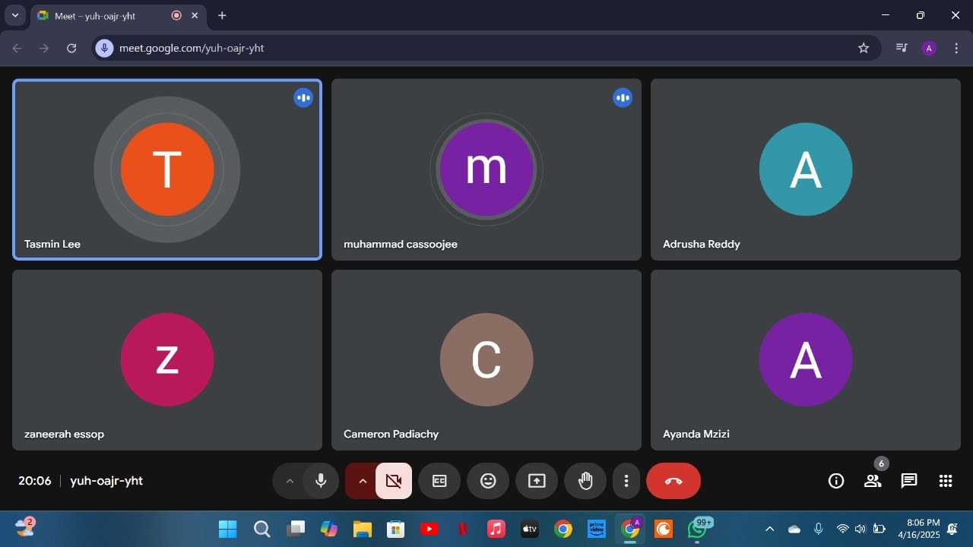
Daily Stand-up summary 2:
We used this meeting to track each groups progress, identify blockers and assign newly emerging tasks to members. We also updated our backlog looking into remaining sprints. This was important as it allowed us to format our website in such a way that it could flow into the next weeks requirements. This would allow us to code more effectively and efficiently. For the current sprint these were the tasks and the members they were assigned to: Create database tables for facilities (Tasmin), Creating a booking page on FE (Zaneerah and Raees), Creating booking logic on BE (Cameron), Creating a booking table in admin page (Tasmin and Cameron), Documentation (Muhammad), Testing user management for staff and admin (Bradley and Adrusha). For sprint 3 we came up with the following requirements: Booking ‘pools’ on resident’s page and Maintenance reporting. For sprint 4 we came up with the following task: reporting problems.
17/04/25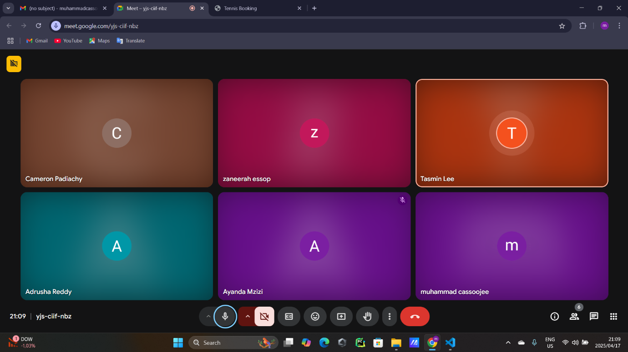
Daily Stand-up Summary 3:
This meeting was used to track blockers and check progress. Zaneerah and Muhammad began working on the booking page but ran into a possible problem. They were concerned on whether to create three separate pages for booking for each individual sport or do it all on a single page. Cameron, who was in progress with booking logic advised them to put it onto a single page. Tasmin and Cameron also now began working on the database for the booking, which Zaneerah and Muhammad could use to finish up their page. Adrusha and Bradley began writing test coverage code for TDD in the meantime.

18/04/25
Tabler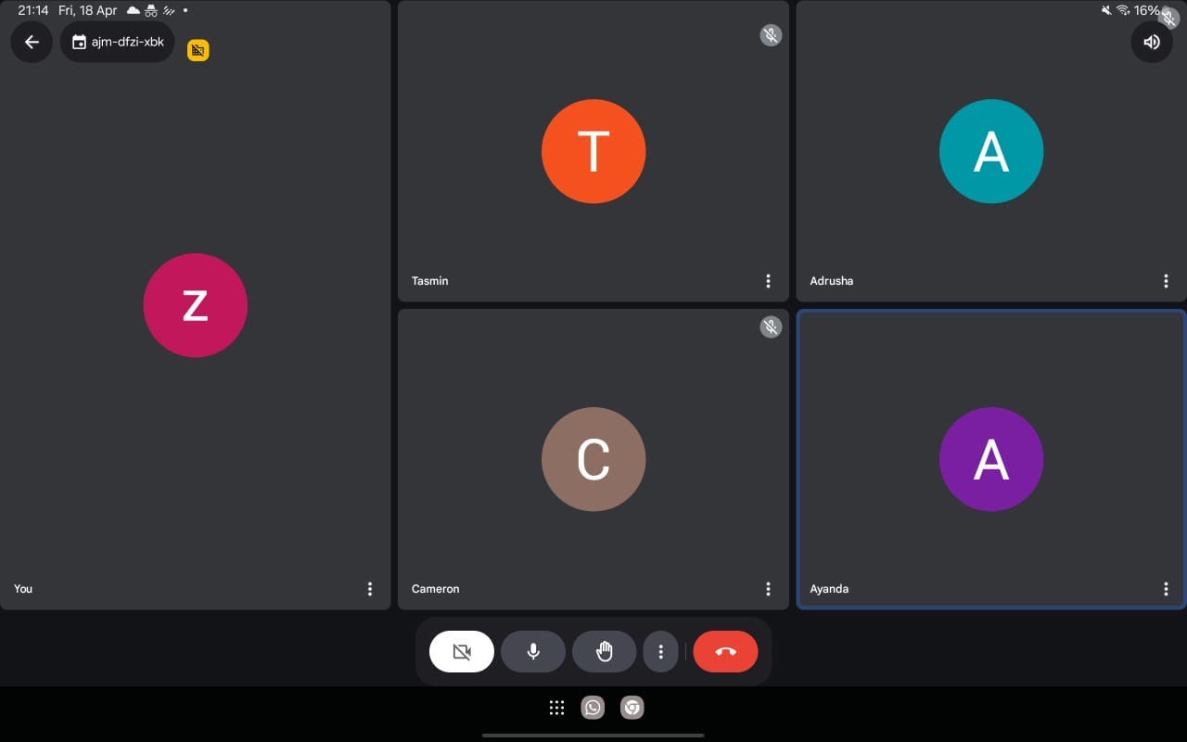
Daily Stand-up meeting 4:
The group continued to do tasks were finishing at a good pace. Tasmin created the database tables for facilities. Zaneerah and Muhammad were almost complete with the booking page. Muhammad was unable to attend this meeting due to an unforeseen circumstance. He did not begin documentation as yet however kept track of the sprint backlog on Notion and sprint meetings.

20/04/25
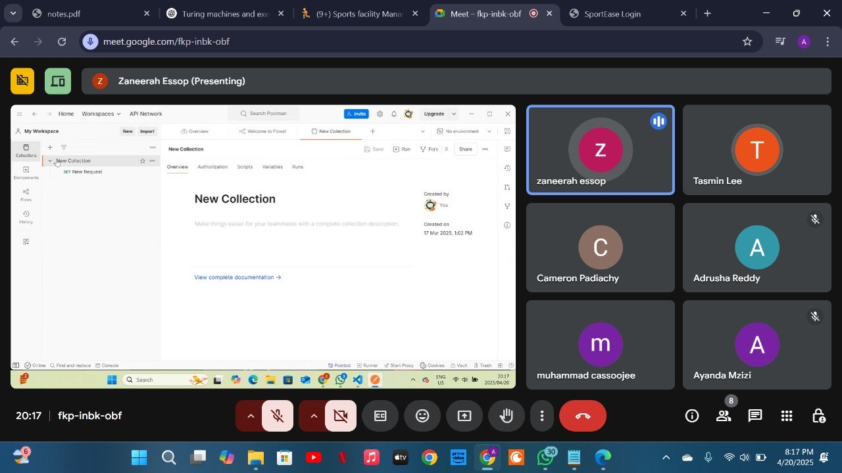
Daily Stand-up Summary 5:
We used this meeting to collectively debug. We were facing issues with booking requests sent to admins and staff and approving them. We collectively organised files into folders separating the code from the tests and correctly naming files to not waste time debugging over simple matters. Muhammad began documentation but struggled with UML diagrams. He did not know what to use however integrated tools like Miro and PlantUML.

21/04/25
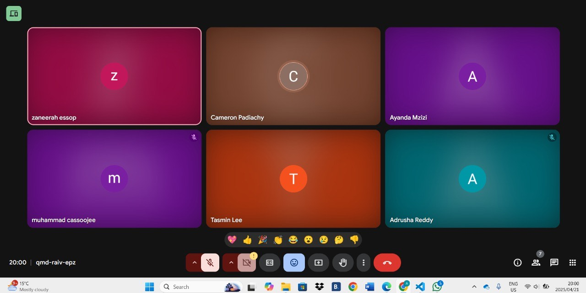
Daily Stand-up Summary 6:
This was our final sprint for the week. We made sure everything ran smoothly without any bugs and problems. Documentation was complete. We began talking about sprint 3 and planning out the rest of the week. There were fortunately not notable blockers for this sprint and everyone’s portion of the work was completed.

Notion (proof of assigned tasks)
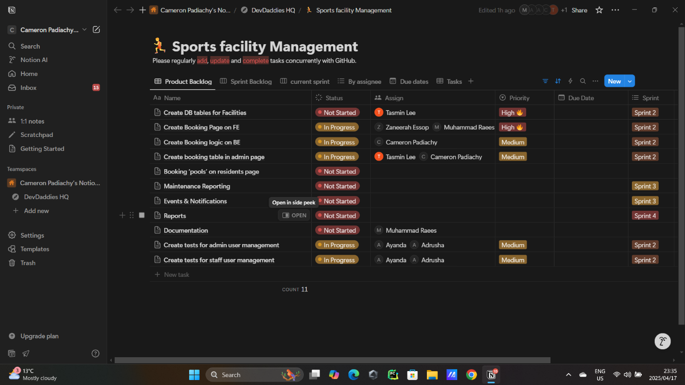

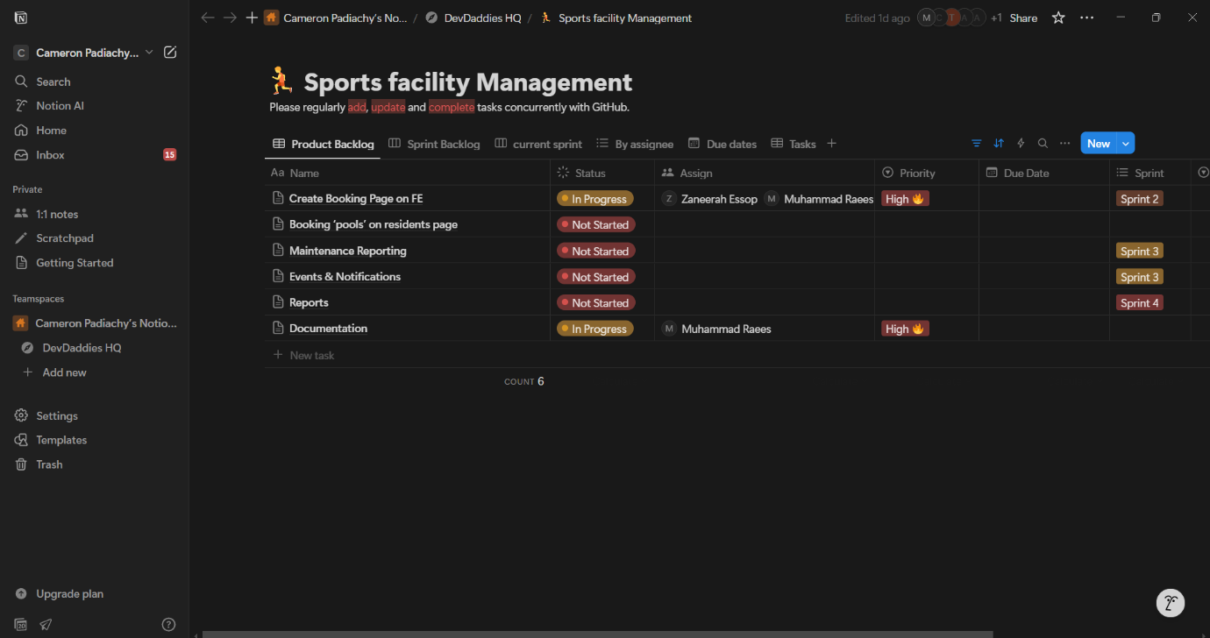
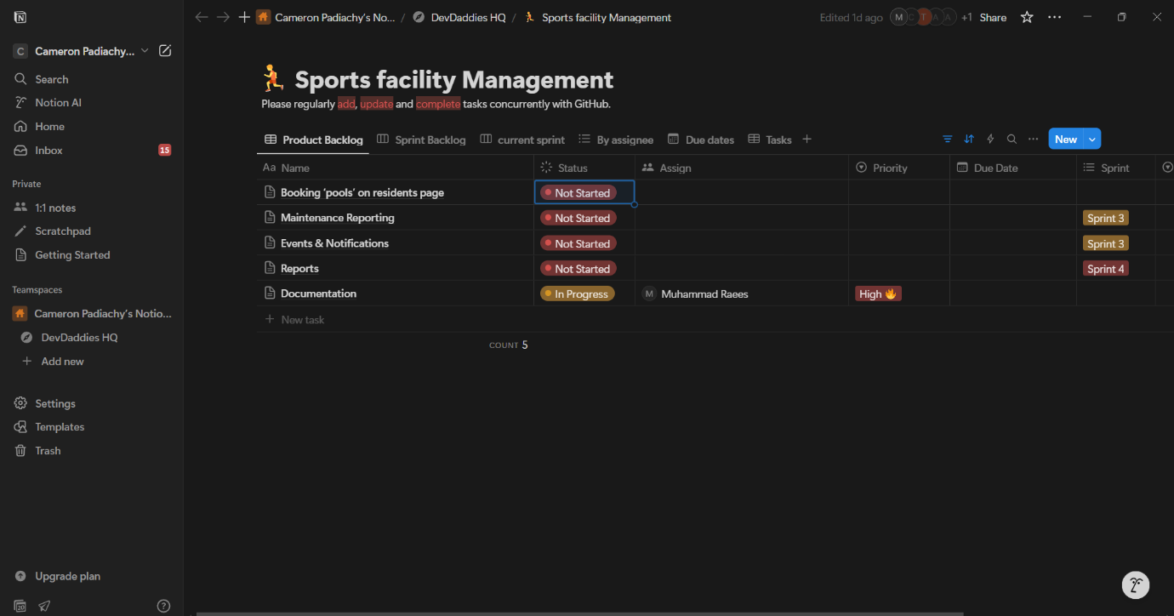

Our backlog automatically removes tasks once they have been completed. The goal was to complete work due for sprint 2 first and use excess time to being sprint 3 and 4 work.

Sprint 2: UML diagrams
Logical view: State diagram
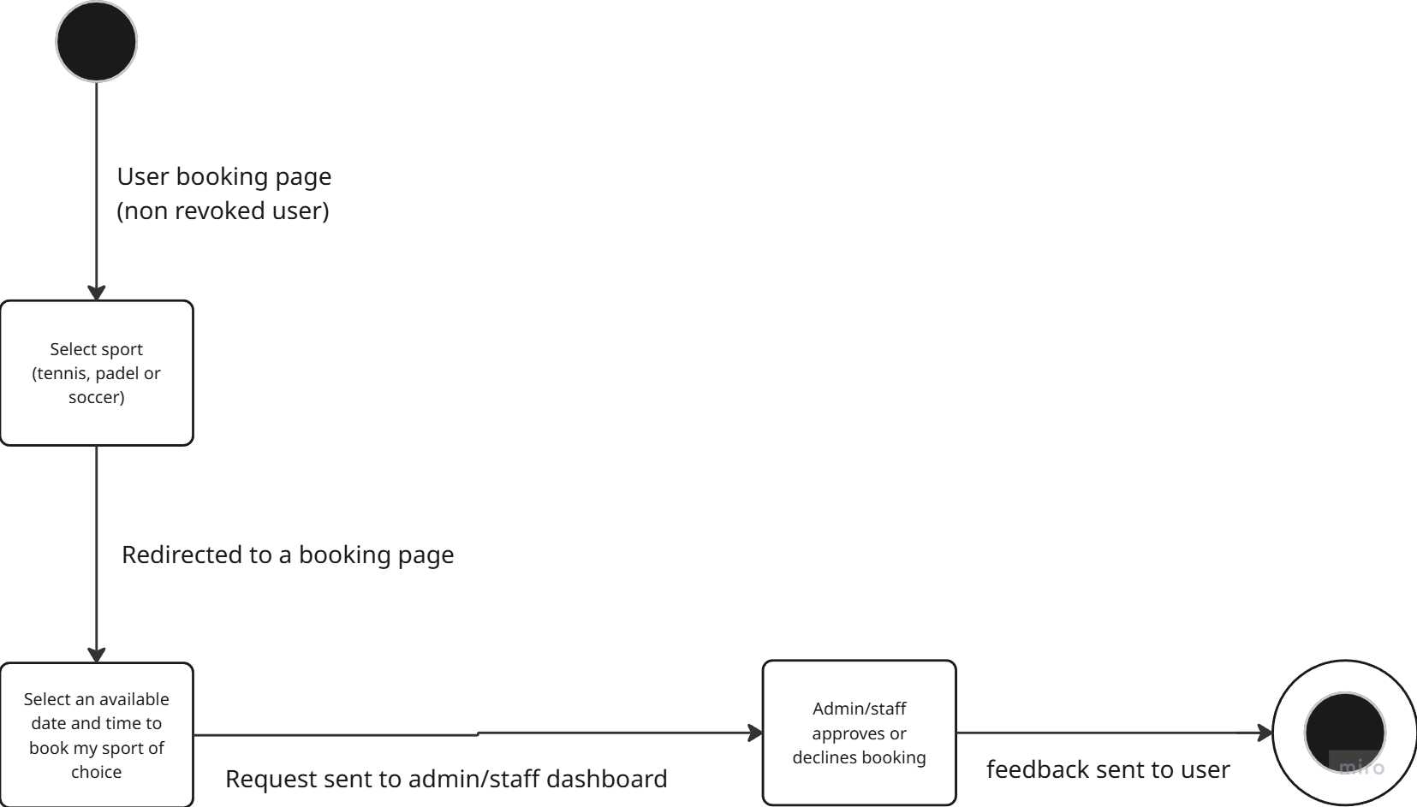

Development view: Component Diagram
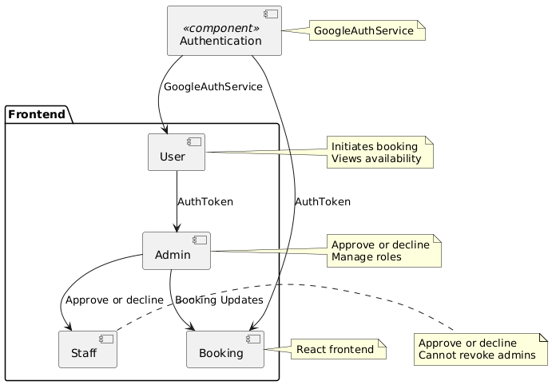
Process View: Sequence diagram
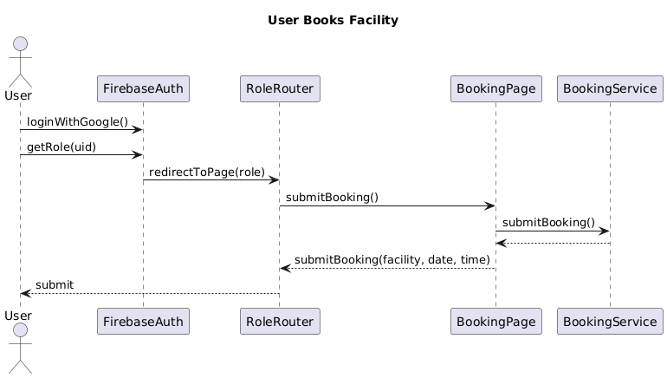

Physical View: Deployment Diagram
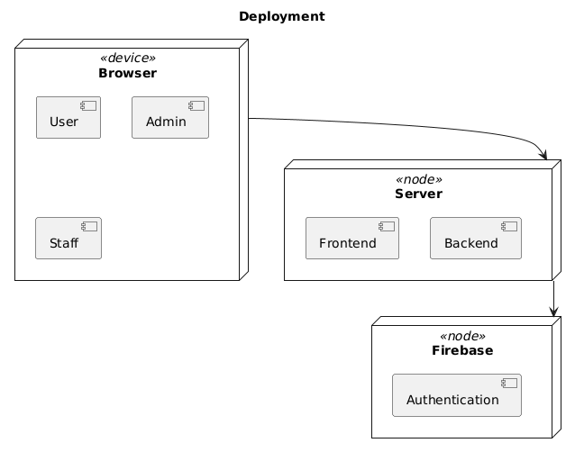

Scenario View: Use Case Diagram

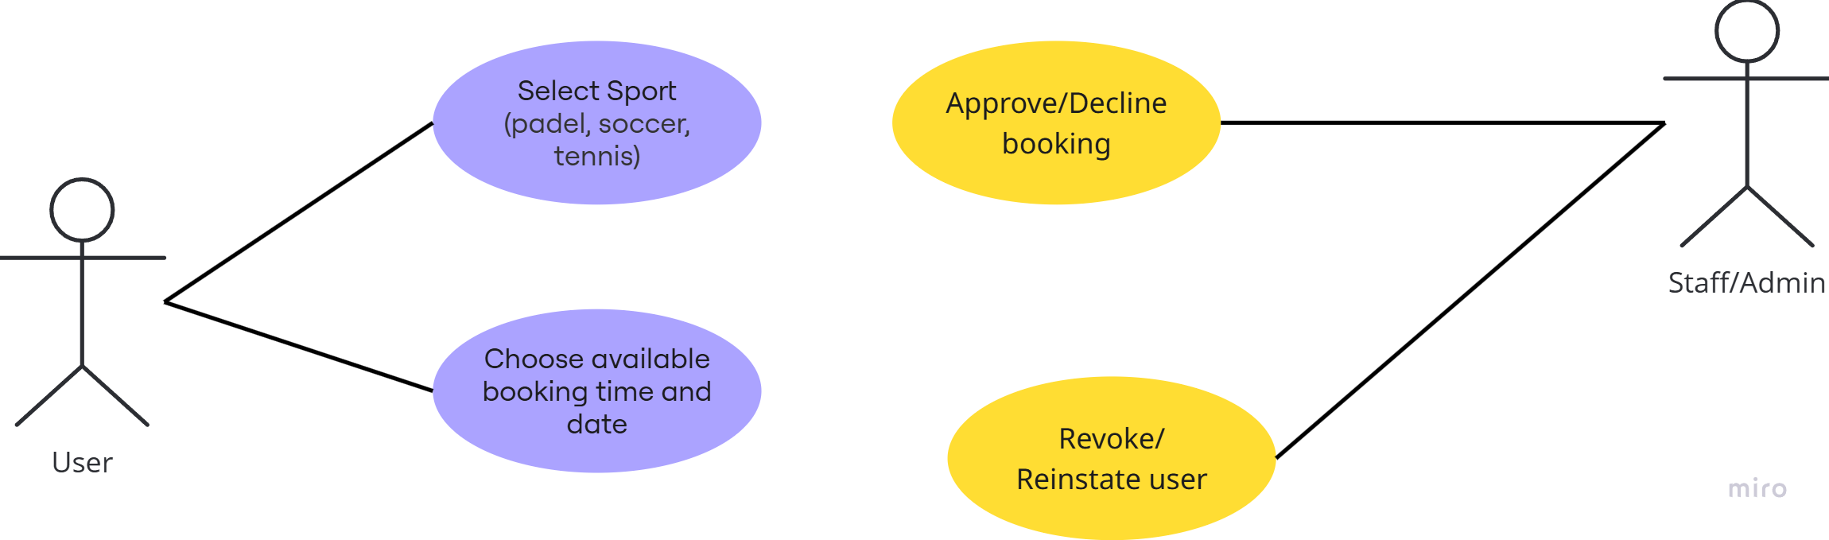

Sprint 2: User Stories
- As a staff member, when on the staff homepage, I should be able to click a button where I can revoke users and reinstate them ultimately contributing to user management.
- As an admin, when on the admin homepage, I should be able to able click a button where I can revoke users and reinstate them ultimately contributing to user management.
- As a user, when on the user homepage, I should be able to select an option where I am able to book either a padel, soccer or tennis game and will then be redirected to a page where I can select an empty slot with a date and time of my choice.
- As a user, when I select the applicable sport, I should be redirected to a page where I can select a date and time of booking.
- As an admin, when on the admin homepage, I should be able to approve or decline a booking made by a user.
- As a staff member, when on the staff homepage, I should be able to approve or decline a booking made by a user.

Sprint 2: Github
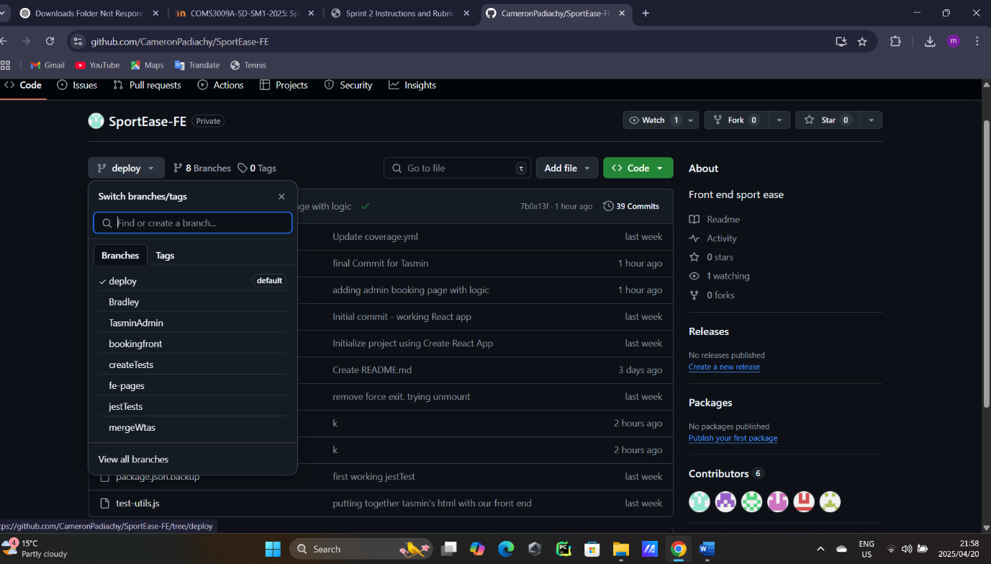
Various branches are created for each member to work on frontend and backend aspects of the task. Coding is done on branches, merged and tested before being added to the deploy branch where the site can be deployed for useability.

Sprint 2: Test Driven Development (TDD)
A code coverage of at least 50% is needed.
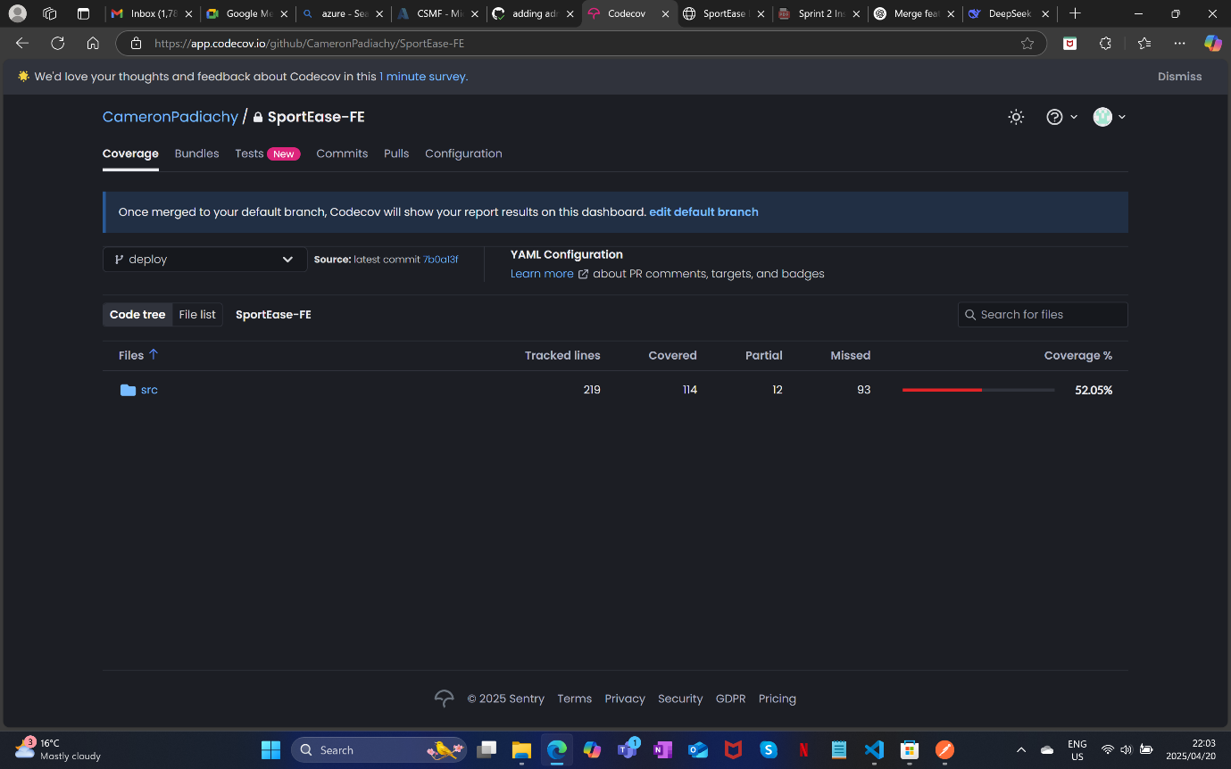
52.05% archieved

